Create Custom Menu Item for users that do NOT need to choose Disposition Action

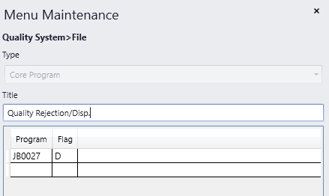

This will grey out the option, so they will not even be able to choose it.

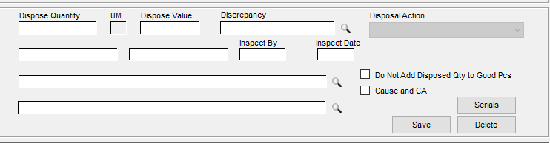

For these users, change the menu permissions to NOT allow access to the standard menu item:

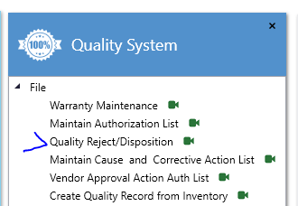

You can control access to either/or in System Support > Group Security Maintenance.

